**CAP777: WEB DEVELOPMENT USING PHP**

**CONTINUOUS ASSESSMENTS (C.A)-2**

**ST_NAME : - EKHLAKH AHMAD**

**REG NO. : - 12209166**

**ROLL NO. : - RD2215B58**

**SECTION : - D2215**

**GROUP : - 2**

**Q.1. You are a school administration, and you want to create a report on the academic performance of your students. This information can be used to identify the schools that are performing the best and to**

**identify the areas where improvement is needed. Webpages contain following information.**

**1. Find the student with highest GPA in each grade level.**

**2. Find the student with the lowest GPA in each grade level.**

**3. Rank of all students**

**4. Subject wise mark order (High to Low)**

**5. Those needed remedial class.**

<!DOCTYPE html>

<html>

<head>

    <title>Academic Performance Report</title>

</head>

<body>

    <h1>Academic Performance Report</h1>

    <?php

    $students = [

        ["name" => "Ekhlakh", "grade" => 7.3, "gpa" => 3.9],

        ["name" => "Ahmad", "grade" => 9, "gpa" => 4.0],

    ];

    usort($students, function ($a, $b) {

        return $b["gpa"] - $a["gpa"];

    });

    $highestGPA = [];

    $lowestGPA = [];

    $remedialNeeded = [];

    foreach ($students as $student) {

        $grade = $student["grade"];

        if (!isset($highestGPA[$grade])) {

            $highestGPA[$grade] = $student;

        }

        $lowestGPA[$grade] = $student;

        if ($student["gpa"] < 2.0) {

            $remedialNeeded[] = $student;

        }

    }

    echo "<h2>Highest GPA Students by Grade:</h2>";

    foreach ($highestGPA as $grade => $student) {

        echo "<p>Grade $grade: " . $student["name"] . " (GPA: " . $student["gpa"] . ")</p>";

    }

    echo "<h2>Lowest GPA Students by Grade:</h2>";

    foreach ($lowestGPA as $grade => $student) {

        echo "<p>Grade $grade: " . $student["name"] . " (GPA: " . $student["gpa"] . ")</p>";

    }

    echo "<h2>Students Needing Remedial Classes:</h2>";

    foreach ($remedialNeeded as $student) {

        echo "<p>" . $student["name"] . " (GPA: " . $student["gpa"] . ")</p>";

    }

    echo "<h2>Ranked List of All Students:</h2>";

    echo "<ol>";

    foreach ($students as $student) {

        echo "<li>" . $student["name"] . " (GPA: " . $student["gpa"] . ")</li>";

    }

    echo "</ol>";

    ?>

</body>

</html>

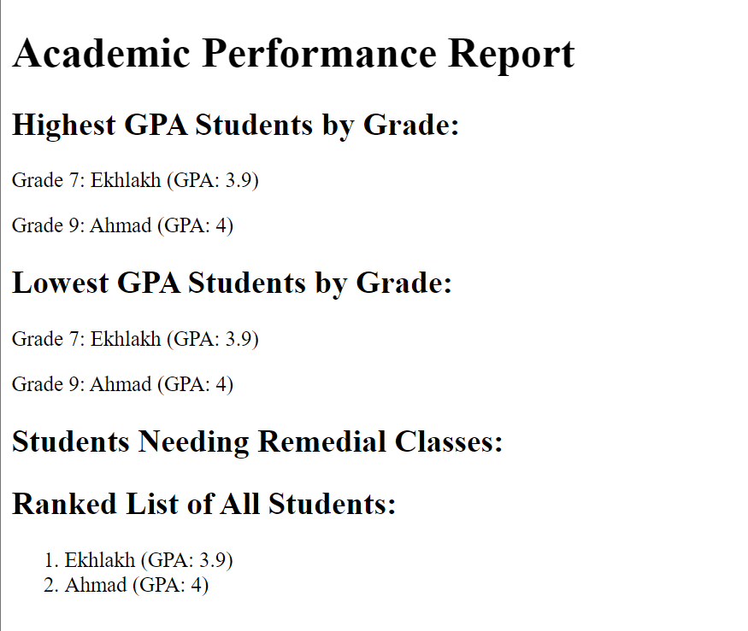

**Q.2. Given an array of numbers, find the first three largest numbers.**

<?php

$arr = [4, 5, 7, 2, 98, 67, 45, 34, 23, 21];

for ($i = 0; $i < count($arr); $i++) {

    for ($j = $i + 1; $j < count($arr); $j++) {

        if ($arr[$i] < $arr[$j]) {

            $temp = $arr[$i];

            $arr[$i] = $arr[$j];

            $arr[$j] = $temp;

        }

    }

}

echo "1st Largest number is " . $arr[0] . "<br>";

echo "2nd Largest number is " . $arr[1] . "<br>";

echo "3rd Largest number is " . $arr[2] . "<br>";

?>

